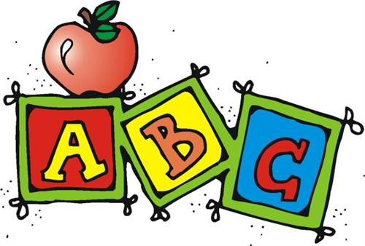
- En binôme, choisissez un dessin sur la table « PICTURES »
- Trouvez le mot correspondant au dessin en anglais. Si besoin, cherchez ce mot dans un dictionnaire dans la partie français-anglais.
Le mot sur lequel nous travaillons est :
................................................
- Cherchez ce mot sur la table « WORDS » et collez-le sous le dessin.
- Sur l’ordinateur, sur le site suivant, écoutez la prononciation de votre mot et répétez -le.
http://dictionary.cambridge.org/pronunciation/english/audio
- Reportez ici sa transcription phonétique :
[ ]
- Sur la table « PHONETICS », retrouvez quel son important de l’anglais votre mot représente.
Notez ce son ici : [ ]
- Collez ce son / signe au bon endroit sous votre dessin.
- Bravo, vous avez réalisé une partie de l’alphabet phonétique qui décorera votre classe et vous sera utile tout au long de l’année.
- S’il reste des dessins sur la table « PICTURES », renouvelez l’opération !
Séance d’AP (accompagnement personnalisé) :
- Réalisez un alphabet phonétique pour la salle de classe.
Illustrated phonetics alphabet

--------------------------------------------------------------------------------------------------------------------------------
- En binôme, choisissez un dessin sur la table « PICTURES »
- Trouvez le mot correspondant au dessin en anglais. Si besoin, cherchez ce mot dans un dictionnaire dans la partie français-anglais.
Le mot sur lequel nous travaillons est :
................................................
- Cherchez ce mot sur la table « WORDS » et collez-le sous le dessin.
- Sur l’ordinateur, sur le site suivant, écoutez la prononciation de votre mot et répétez -le.
http://dictionary.cambridge.org/pronunciation/english/audio
- Reportez ici sa transcription phonétique :
[ ]
- Sur la table « PHONETICS », retrouvez quel son important de l’anglais votre mot représente.
Notez ce son ici : [ ]
- Collez ce son / signe au bon endroit sous votre dessin.
- Bravo, vous avez réalisé une partie de l’alphabet phonétique qui décorera votre classe et vous sera utile tout au long de l’année.
- S’il reste des dessins sur la table « PICTURES », renouvelez l’opération !
Séance d’AP (accompagnement personnalisé) :
- Réalisez un alphabet phonétique pour la salle de classe.
Illustrated phonetics alphabet

